ITCS216: Database Management Systems (1/2026)

Faculty of Information and Communication Technology
Workshop on Project Phase 1: Data Modeling

This workshop aims to provide a chance to refine the business rules and develop the data model for Project Phase I. All members of the team are required to analyze the business requirements (both rules and constraints) and sketch the data model using ERD Chen Notations.
Instructions:
- Use the group project to do an individual assignment.
- Starting from the M1 report, each member picks the different business process.
- Revise / or create at least 3 business rules using Template#1.
Template#1: Format: Noun + Verb + Noun (e.g., a student enrolls many classes)
Business Process Name: Enrollment
Rule No. 1 | Rule Statement | Relationship
Forward/Active | A student can enroll many classes. | 1:M
Backward/Passive | A class can be enrolled by many students. | 1:M
Conclusion | Students can enroll many classes. | M:N
Note: you need to formulate both Backward and Forward

Business Process Name: Class Registration
Rule No. 1 | Rule Statement | Relationship
Forward/Active | A member can register many classes. | 1:M
Backward/Passive | A class can be registered by many members | 1:M
Conclusion | Many members can register many classes. | M:N
Rule No. 2 | Rule Statement | Relationship
Forward/Active | A instructor can teach many classes. | 1:M
Backward/Passive | A class can only be taught by one instructor | 1:1
Conclusion | A instructor can teach many classes. | 1:M
Rule No. 3 | Rule Statement | Relationship
Forward/Active | A class can book many room. | 1:M
Backward/Passive | A room can be booked for many class. | 1:M
Conclusion | Many classes can book many rooms | M:N

4. Revise / or create at least 2 business rules using Template#2.
Template#2: Format: Noun + Verb + Attributes (e.g., a student comprises of ID, Name, Email),
Business Process Name: Enrollment
Rule No. 2
A student comprises of ID, Name, Birthdate, and calculated Age.

Rule No. 8
A class registration must contain Booking ID, Class ID, Instructor ID, scheduled session timestamp, member reservation status, and class remain capacity.
Rule No. 9
A member can only register one class at one time slop, no overlapping allowed.

- Use the results obtained from Step 2-3 to draw the ERD (CHEN notation) using Template #3. All necessary notations for each rule have to demonstrate with complete and correct design

Template #3: Example
Business Process Name: Enrollment
Rule No. 1 | Many students can register many classes.
Rule No. 2 | A instructor can teach many classes.
Rule No. 3 | Many classes can book many rooms
Rule No. 4 | A class registration must contain Booking ID, Class ID, Instructor ID, scheduled session timestamp, member reservation status, and class remain capacity.
Rule No. 5 | A member can only register one class at one time slop, no overlapping allowed.
ERD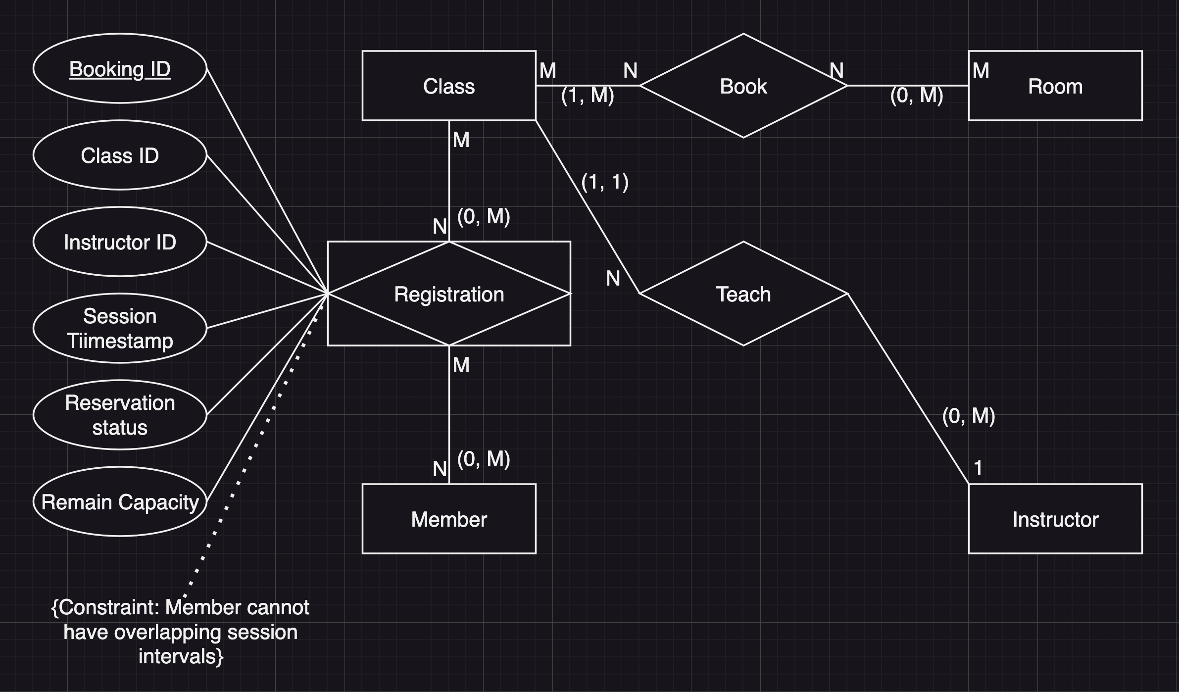

Template #3: Example
Business Process Name: Class Registration
Rule No. 1 | Students can enroll many classes. (M:N)
Rule No. 2 | A student comprises of ID, Name, Birthdate, and calculated Age.
Rule No. X | A class consists of class code and name.
…
ERD
ID
Code
N
M

Student
Class
enroll
Name
(1, M)
Name
(1, N)
Age
BDate

- Use the result from your teammate to create only one EERD diagram per group.
(Recommended Tools: https://www.drawio.com/)

